Signal Description: ______________________________- Node ID: _____._____._____._____
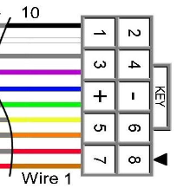
Signal Mast Designation: _________________________ Mast Head(s) Used: ________________
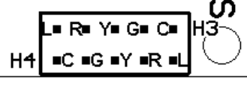
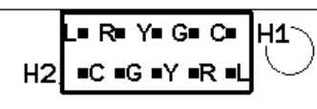
H1: 1 Com ____ H2: 2 L ___ H3: 1 Com ____ H4: 2 L ___
3 G ____ 4 R ___ 3 G ____ 4 R ___
5 Y ____ 6 Y ___ 5 Y ____ 6 Y ___
7 R ____ 8 G ___ 7 R ____ 8 G ___
9 L ____ 10 Com ___ 9 L ____ 10 Com ___
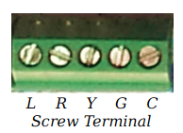
Note: Connector Pin Numbers are OPPOSITE of Cable Wire numbers. Wire 1 is red.
Signal-LCC-P Signal-LCC-S I/O Wiring:
Connection Connector Wire No Layout
Name Pin # Ref
Line 1 10 1 ________________________________
Line 2 9 2 ________________________________
Line 3 8 3 ________________________________
Line 4 7 4 ________________________________
+5 VDC 6 5 ________________________________
Ground 5 6 ________________________________
Line 1 Line 5 4 7 ________________________________
Line 6 3 8 ________________________________
Line 7 2 9 ________________________________
Line 8 1 10 ________________________________

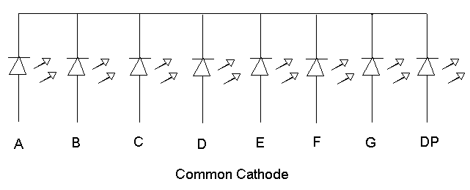
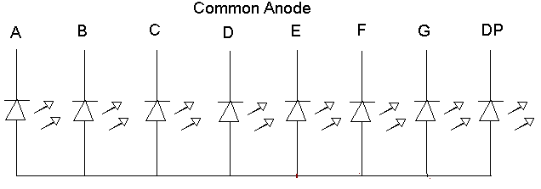
I/O-1 Connector Wiring Common Anode: Common Cathode:

